XCRAM
Use Case Specification

Submitted to:

Asst. Prof. Ma. Rowena C. Solamo
Faculty Member
Department of Computer Science
College of Engineering
University of the Philippines, Diliman

Submitted by:
Agluba, Gerry P.
Go, Sharleen Joy Y.
Silverio, Robelle C.

In partial fulfillment of academic requirements for the course

CS 191 Software Engineering I of the

1st Semester, AY 2016-2017

System: Task Scheduling System Page: 1
Version: 2.0 Group: TaskOverflow
Unique Reference:

The documents are stored in the https://github.com/sharleengo/XCRAM/tree/master/02-Requirements-Engineering

Document Purpose:

The purpose of this document is to present the use case specification of “Save Current Schedule‟ use case.

Target Audience:

Evaluators and users.

Revision Control

History Revision:
Revision | Person | Version | Modification
Date | Responsible | Number
09/29/16 | Robelle Silverio | 1.0 | Specified purpose, target audience, use case
 |  |  | name, use case precondition, flow of events
 |  |  | (scenarios along with its description). Added
 |  |  | activity diagram.
09/29/16 | Sharleen Joy Go | 1.1 | Added use case description.
11/22/16 | Robelle Sivlerio | 2.0 | Edited unique reference and use case name

System: Task Scheduling System Page: 2
Version: 2.0 Group: TaskOverflow

Use-Case Name:

Description:

Use-Case 5.0 Save Current Schedule

If the User wishes to save the current schedule for future use, he may do so through this use-case. The User will be asked to name the current schedule, then this use-case will add the schedule to the list of saved schedules. This use-case will come in handy when there is some set of tasks which needs to be repeated in the future given the exact same conditions for each task.

Preconditions:

Flow of Events:

There is at least one task to be saved.

Scenario Name |  | Description
Scenario 1 (Basic Flow) | 1. The User wished to save the current schedule he/she has for that
User chooses to save current | particular day.
schedule and gives a unique | 2. System will ask user to input a name for the schedule he/she wanted to
name for the schedule to be | save.
saved | 3. | User inputs a name.
 | 4. | Schedule‟s name is unique.
 | 5. | System will add to the list of saved schedule/s the just named current
 | schedule.
 | 6. | End of the use „Save Current Schedule”.
Scenario 2 (Alternative Flow) | 1. The User wished to save the current schedule he/she has for that
User chooses to save current | particular day.
schedule and doesn‟t give a | 2. System will ask user to input a name for the schedule he/she wanted to
name for the schedule to be | save.
saved | 3. | User doesn‟t enter a name.
 | 4. | System will give a message to the user, “No name entered”
 | 6. | End of the use case „Save Current Schedule‟.
Scenario 3 (Alternative Flow) | 1. The User wished to save the current schedule he/she has for that
User chooses to save current | particular day.
schedule and doesn‟t give a | 2. System will ask user to input a name for the schedule he/she wanted to
unique name for the schedule | save.
to be saved | 3. | User inputs a name.
 | 4. | Schedule‟s name is not unique.
 | 5. | System will give a message to the user,” Schedule‟s name is already
 | used”.
 | 6. | End of the use case „Save Current Schedule‟.

System: Task Scheduling System Page: 3
Version: 2.0 Group: TaskOverflow
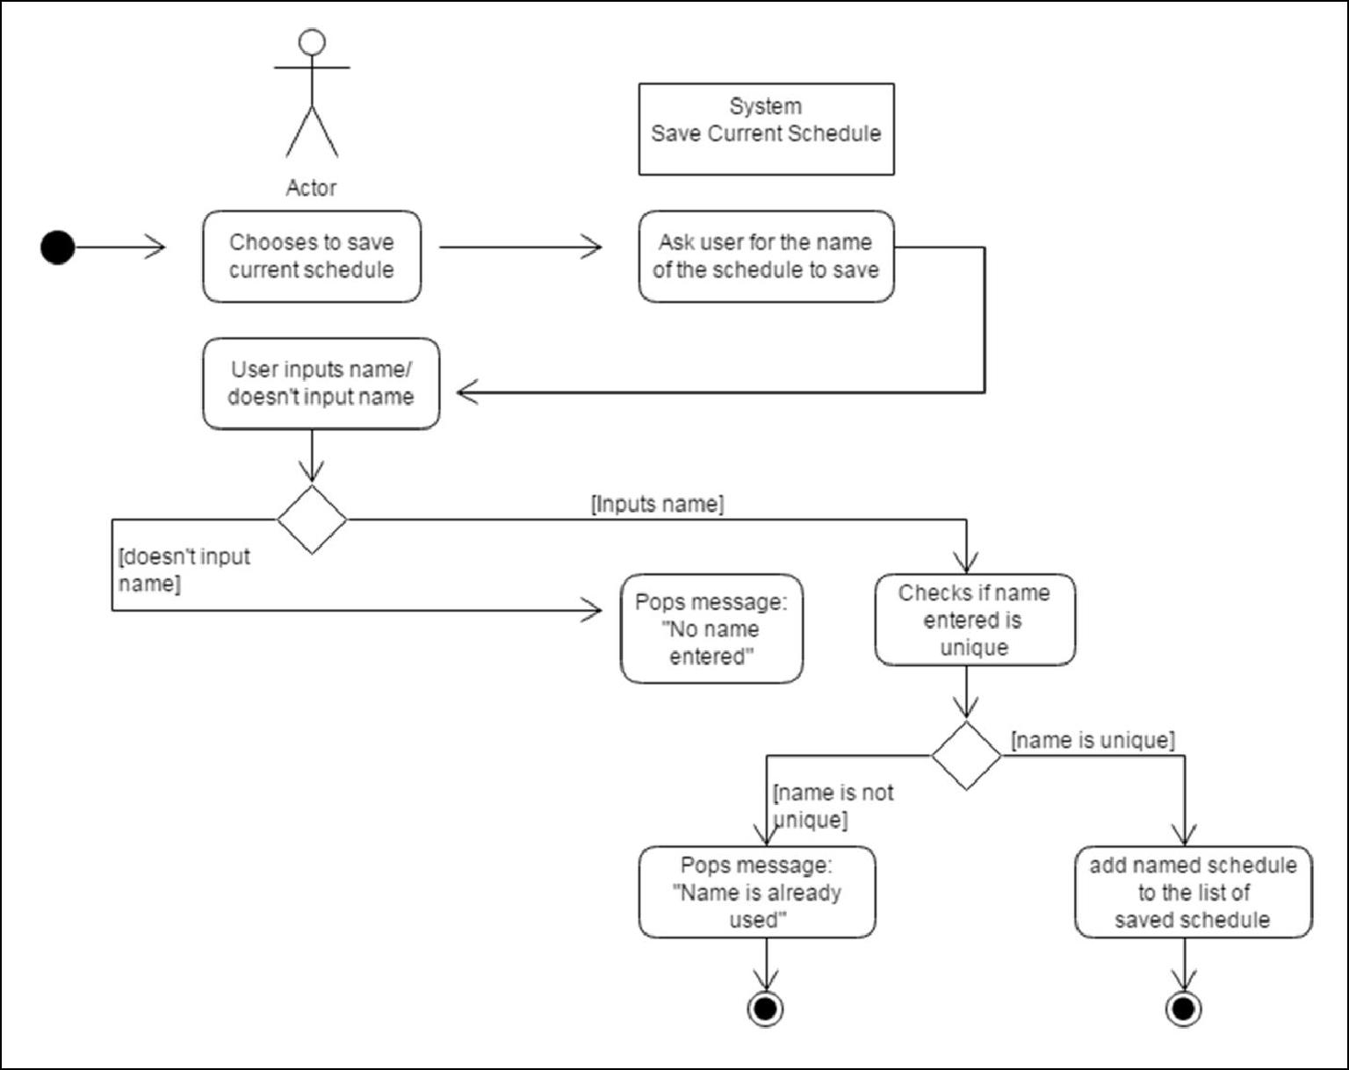

Activity Diagram of the flow of events:

System: Task Scheduling System Page: 4
Version: 2.0 Group: TaskOverflow

Post Condition: An added saved schedule must be part of the list of saved schedule/s represented by the name of the schedule.

Relationship: None

Special Requirements: None

System: Task Scheduling System Page: 5
Version: 2.0 Group:TaskOverflow

